**SQL Views:**

Applicants_info:

CREATE VIEW Applicants_info AS

SELECT first_name,last_name,date_of_birth,email,phone_number

FROM Applicants

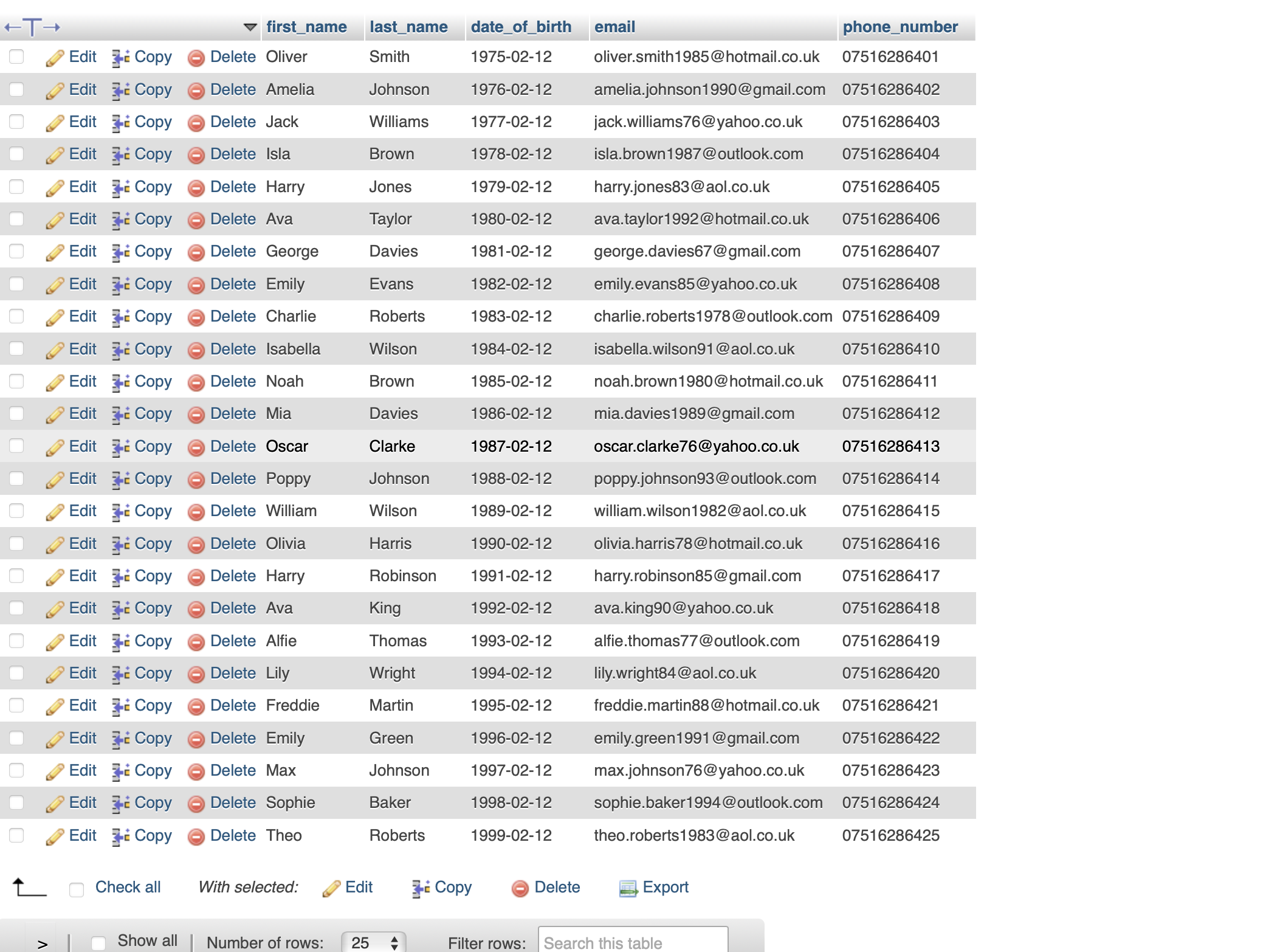

CV_info view:

[CREATE](https://webhost1.eeecs.qub.ac.uk/phpmyadmin/url.php?url=https://dev.mysql.com/doc/refman/8.0/en/create-view.html) [VIEW](https://webhost1.eeecs.qub.ac.uk/phpmyadmin/url.php?url=https://dev.mysql.com/doc/refman/8.0/en/create-view.html) CV_info AS [SELECT](https://webhost1.eeecs.qub.ac.uk/phpmyadmin/url.php?url=https://dev.mysql.com/doc/refman/8.0/en/select.html) first_name,last_name,file_name,CV_link,Date_recived FROM Attachment;

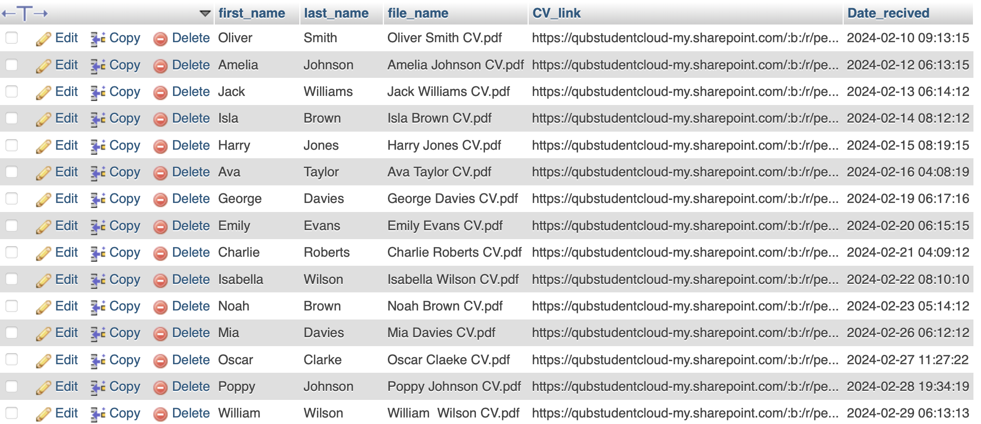

Application_status view:

[CREATE](https://webhost1.eeecs.qub.ac.uk/phpmyadmin/url.php?url=https://dev.mysql.com/doc/refman/8.0/en/create-view.html) [VIEW](https://webhost1.eeecs.qub.ac.uk/phpmyadmin/url.php?url=https://dev.mysql.com/doc/refman/8.0/en/create-view.html) Application_status AS [SELECT](https://webhost1.eeecs.qub.ac.uk/phpmyadmin/url.php?url=https://dev.mysql.com/doc/refman/8.0/en/select.html) application_submition_date,is_applicatinon_active FROM Applications;

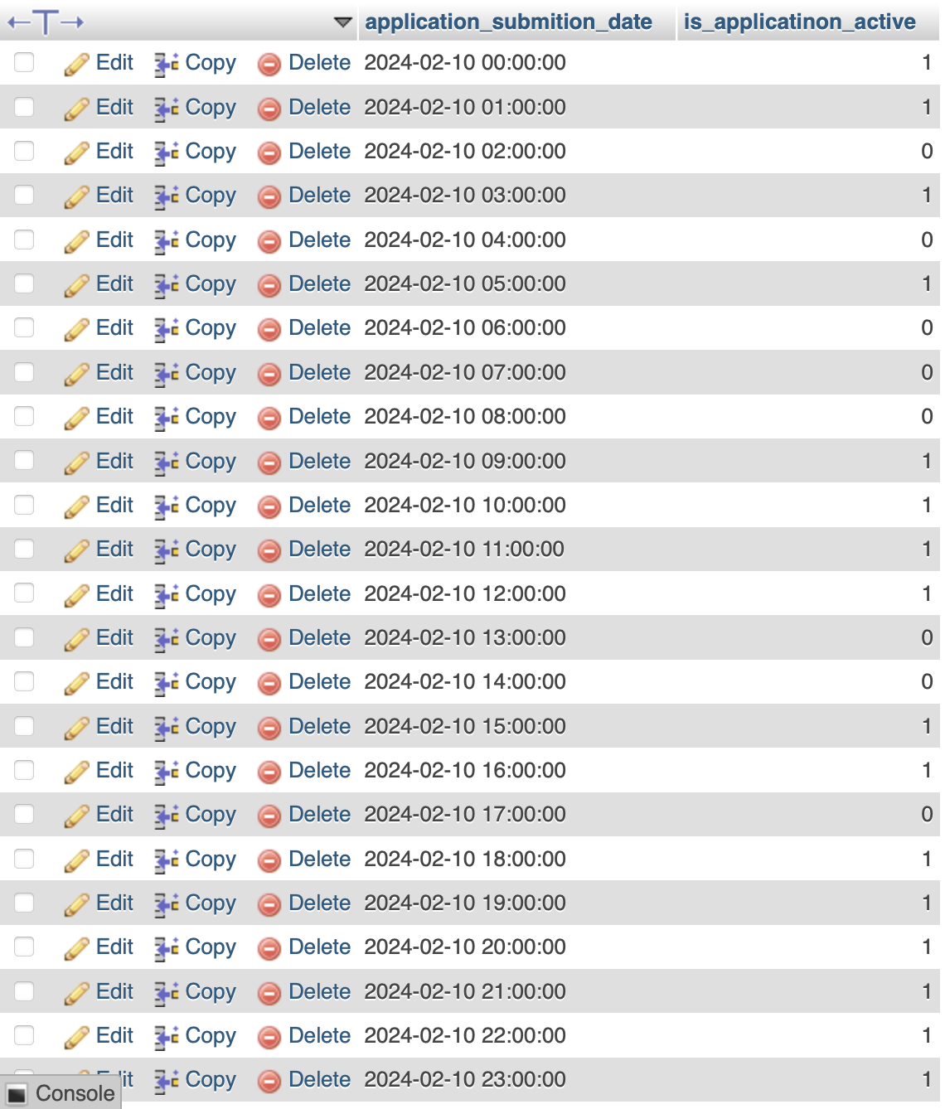

Employer_Info View:

[CREATE](https://webhost1.eeecs.qub.ac.uk/phpmyadmin/url.php?url=https://dev.mysql.com/doc/refman/8.0/en/create-view.html) [VIEW](https://webhost1.eeecs.qub.ac.uk/phpmyadmin/url.php?url=https://dev.mysql.com/doc/refman/8.0/en/create-view.html) Employer_Info AS [SELECT](https://webhost1.eeecs.qub.ac.uk/phpmyadmin/url.php?url=https://dev.mysql.com/doc/refman/8.0/en/select.html) Company_name,first_name,last_name,email,job_title,Industry,business_phone FROM Employer;

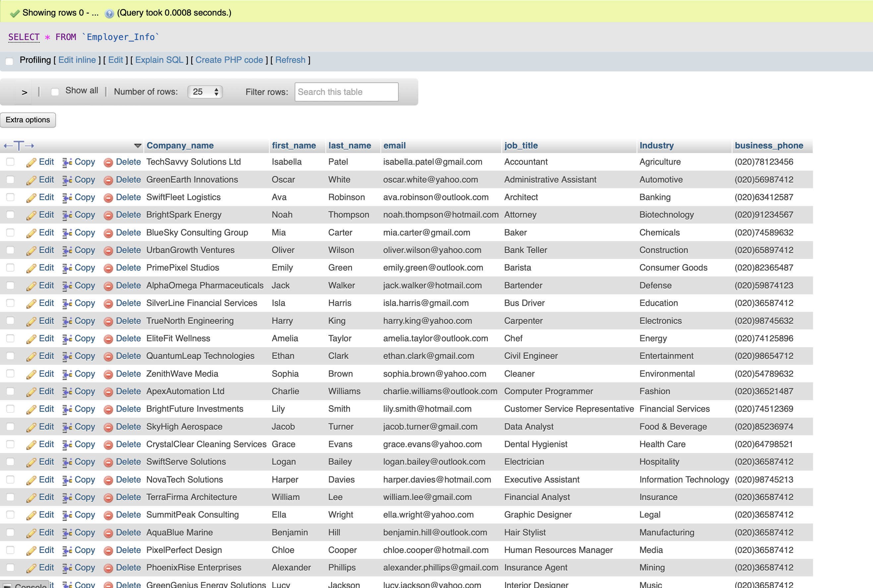

Company_Info View:

[CREATE](https://webhost1.eeecs.qub.ac.uk/phpmyadmin/url.php?url=https://dev.mysql.com/doc/refman/8.0/en/create-view.html) [VIEW](https://webhost1.eeecs.qub.ac.uk/phpmyadmin/url.php?url=https://dev.mysql.com/doc/refman/8.0/en/create-view.html) Company_Info AS [SELECT](https://webhost1.eeecs.qub.ac.uk/phpmyadmin/url.php?url=https://dev.mysql.com/doc/refman/8.0/en/select.html) Company_name,business_phone,Street,City,Postcode FROM Employers;

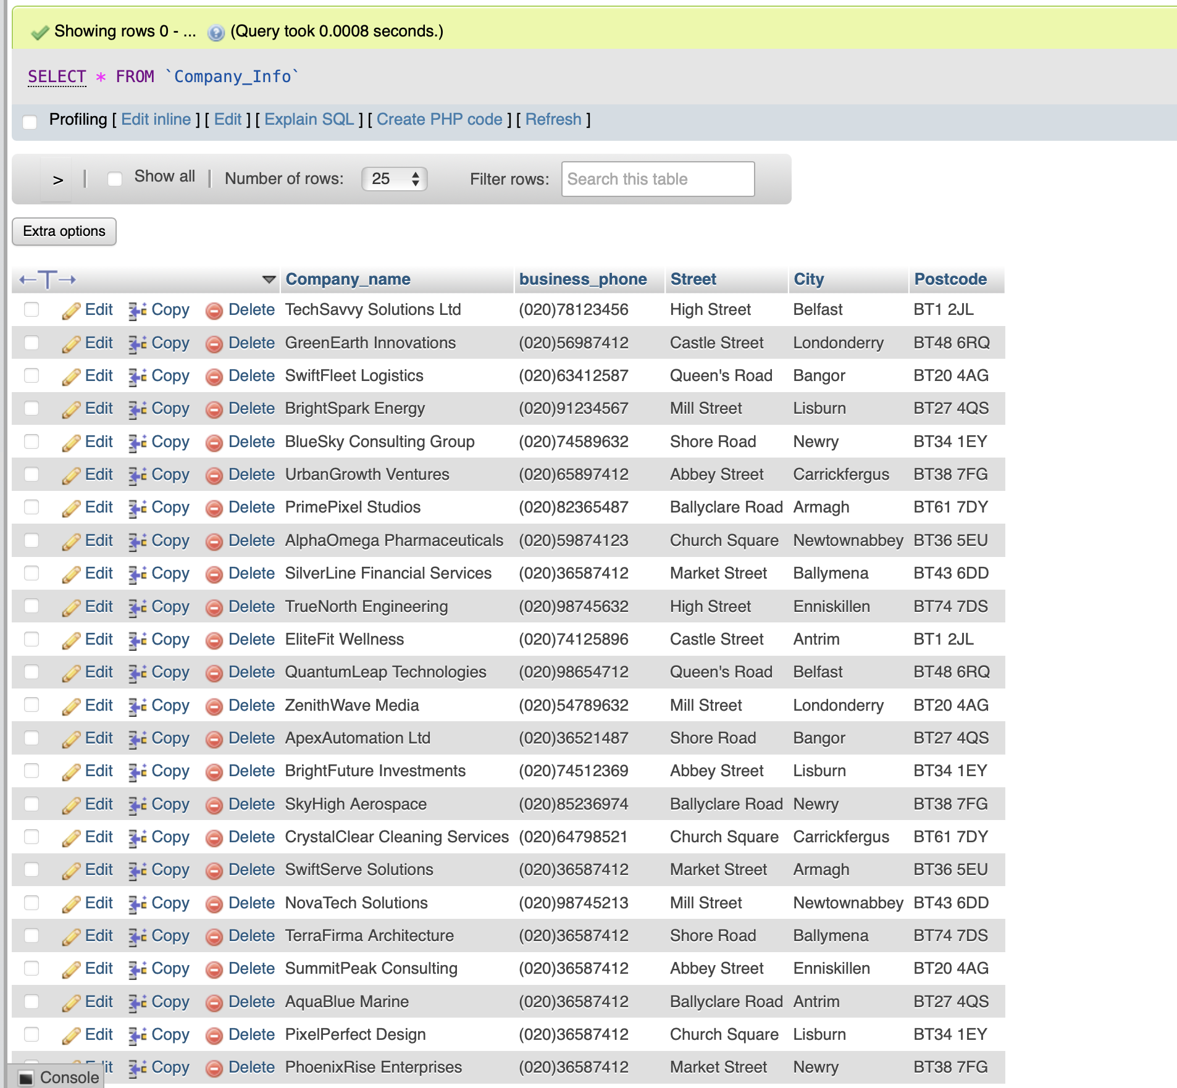

Jobs_Details view:

[CREATE](https://webhost1.eeecs.qub.ac.uk/phpmyadmin/url.php?url=https://dev.mysql.com/doc/refman/8.0/en/create-view.html) [VIEW](https://webhost1.eeecs.qub.ac.uk/phpmyadmin/url.php?url=https://dev.mysql.com/doc/refman/8.0/en/create-view.html) Jobs_Details AS [SELECT](https://webhost1.eeecs.qub.ac.uk/phpmyadmin/url.php?url=https://dev.mysql.com/doc/refman/8.0/en/select.html) job_title,Job_description, Yearly_Salary,Job_type,City FROM Jobs;

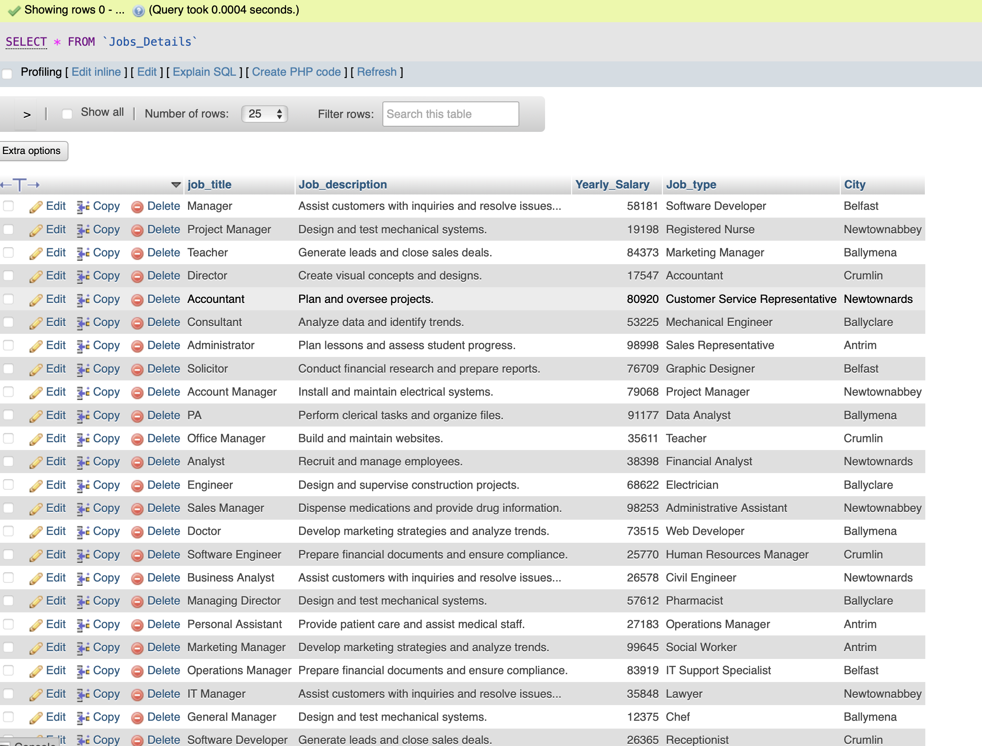

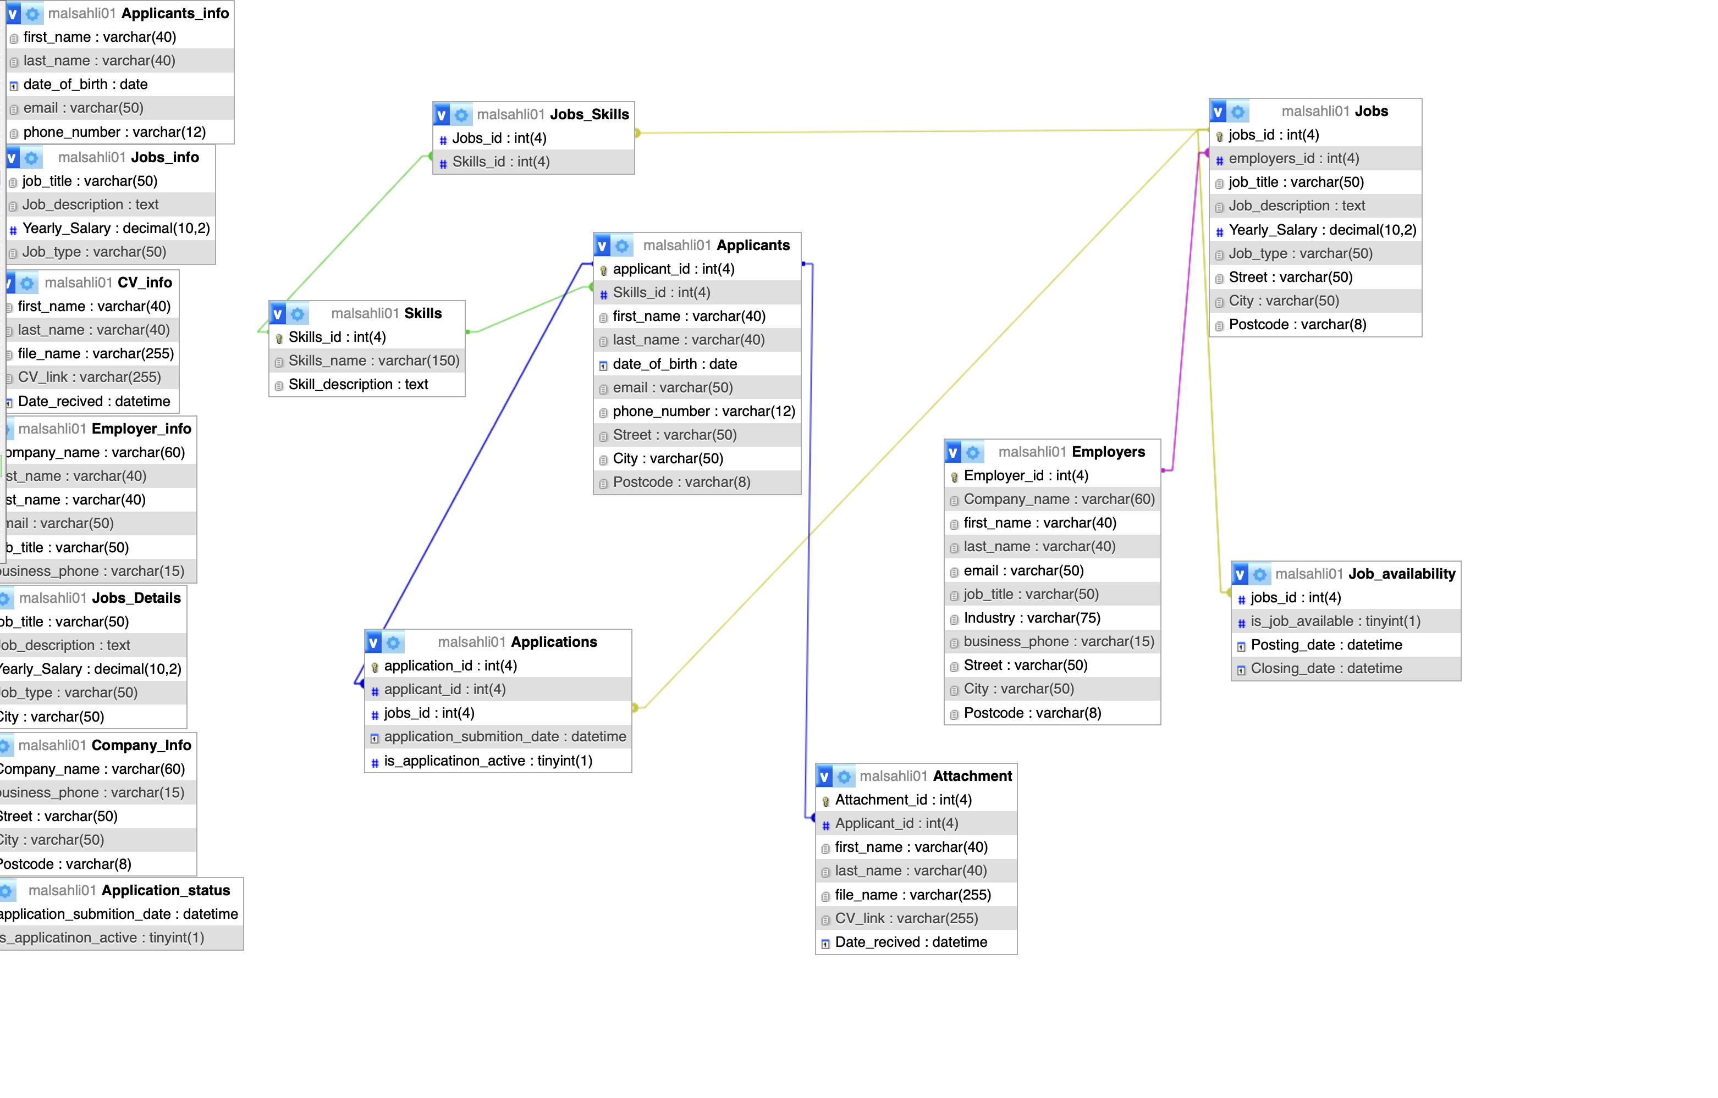

**WHERE Clause:**

SELECT * FROM `Applicant` WHERE first_name = 'Oliver'

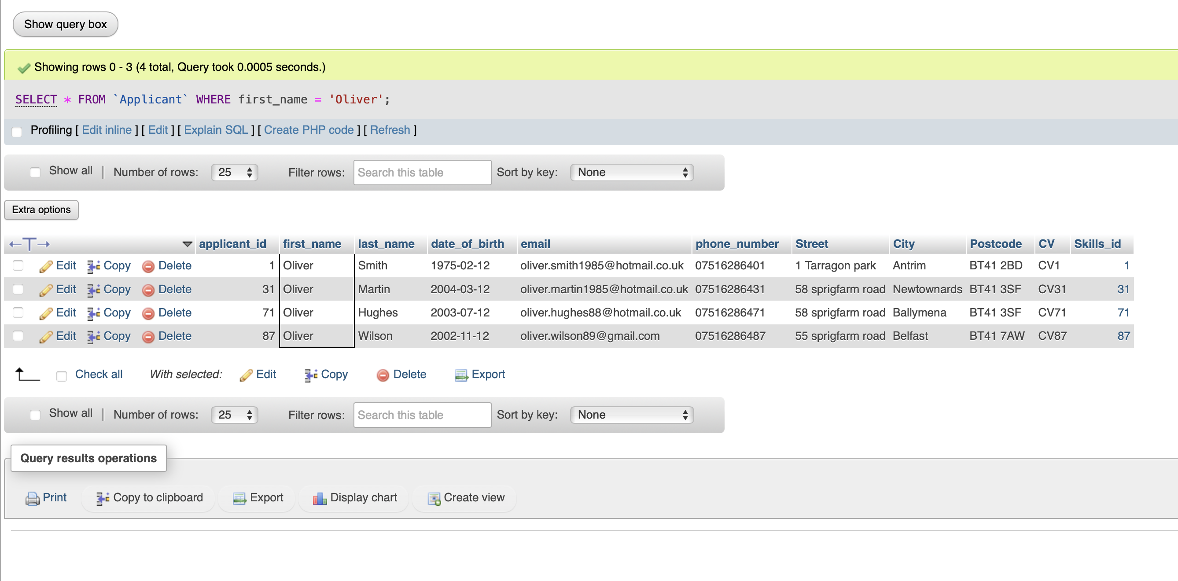

SELECT * FROM `Applicant` WHERE date_of_birth = '1998-02-12'

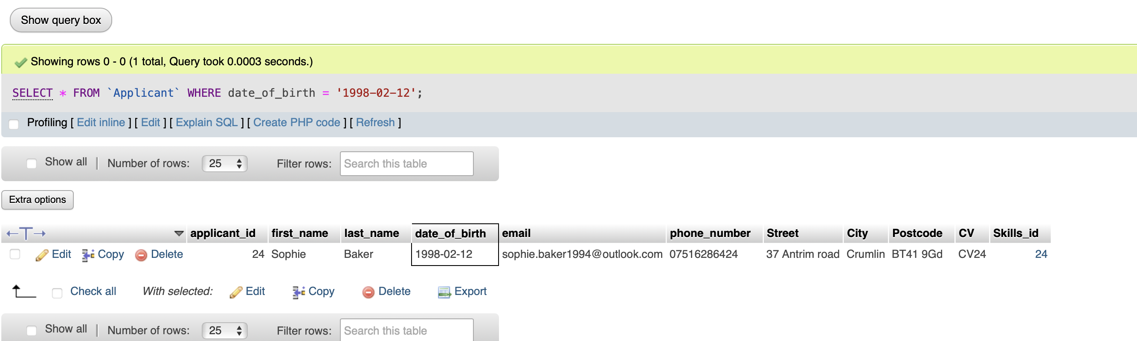

SELECT * FROM ‘Jobs’ WHERE Job_type = ‘Resgistered Nurse’;

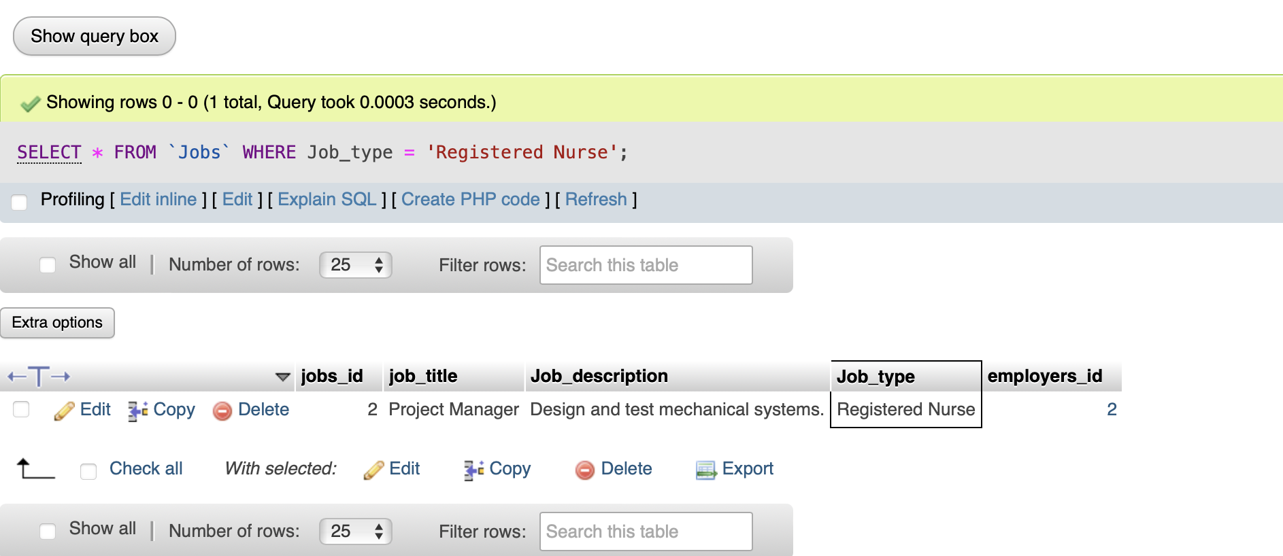

SELECT * FROM ‘`Jobs’ WHERE ‘Job_type = ‘Lawyer’;

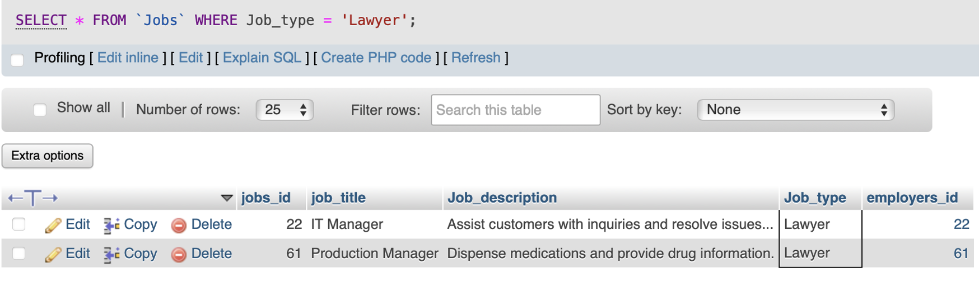

Join quires:

[SELECT](https://webhost1.eeecs.qub.ac.uk/phpmyadmin/url.php?url=https://dev.mysql.com/doc/refman/8.0/en/select.html) ap.first_name, ap.last_name, ap.email, s.Skills_name FROM Applicants ap INNER JOIN Skills s ON ap.Skills_id = s.Skills_id;

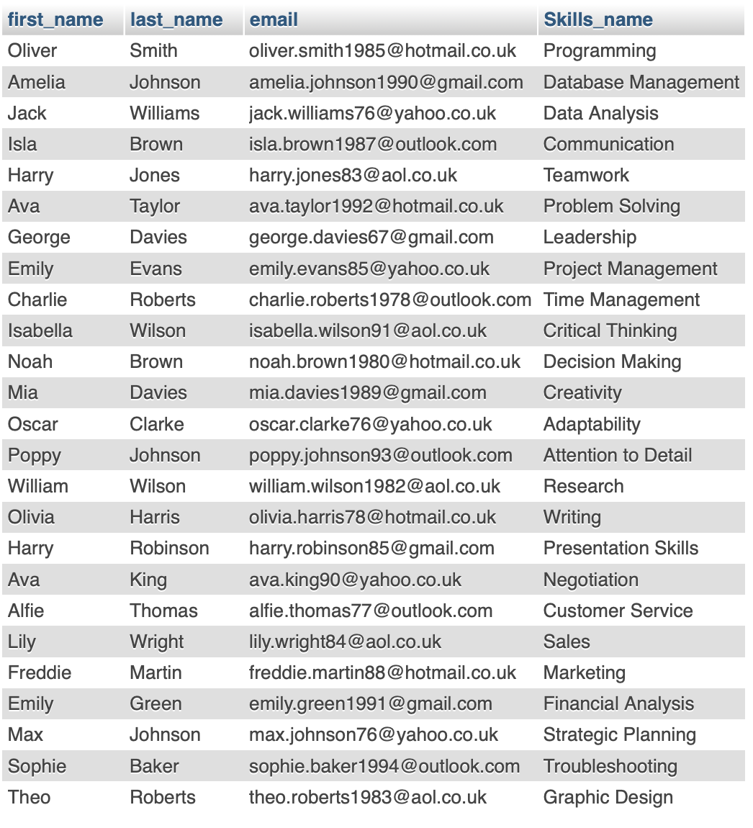

Group by and Order by:

[SELECT](https://webhost1.eeecs.qub.ac.uk/phpmyadmin/url.php?url=https://dev.mysql.com/doc/refman/8.0/en/select.html) City, [COUNT](https://webhost1.eeecs.qub.ac.uk/phpmyadmin/url.php?url=https://dev.mysql.com/doc/refman/8.0/en/aggregate-functions.html%23function_count)(Employer_id) AS Employers_count FROM Employers GROUP BY City ORDER BY Employers_count DESC;

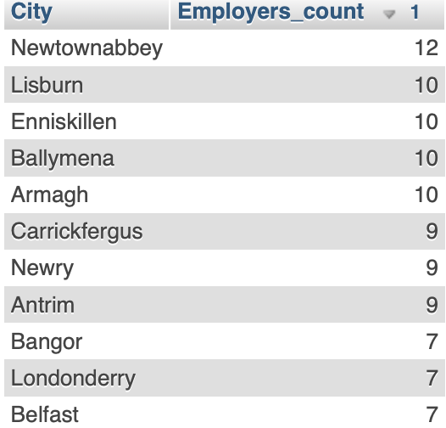

[SELECT](https://webhost1.eeecs.qub.ac.uk/phpmyadmin/url.php?url=https://dev.mysql.com/doc/refman/8.0/en/select.html) a.first_name, a.last_name, a.email, a.date_of_birth FROM Applicants a INNER JOIN Applications app ON a.applicant_id = app.applicant_id;

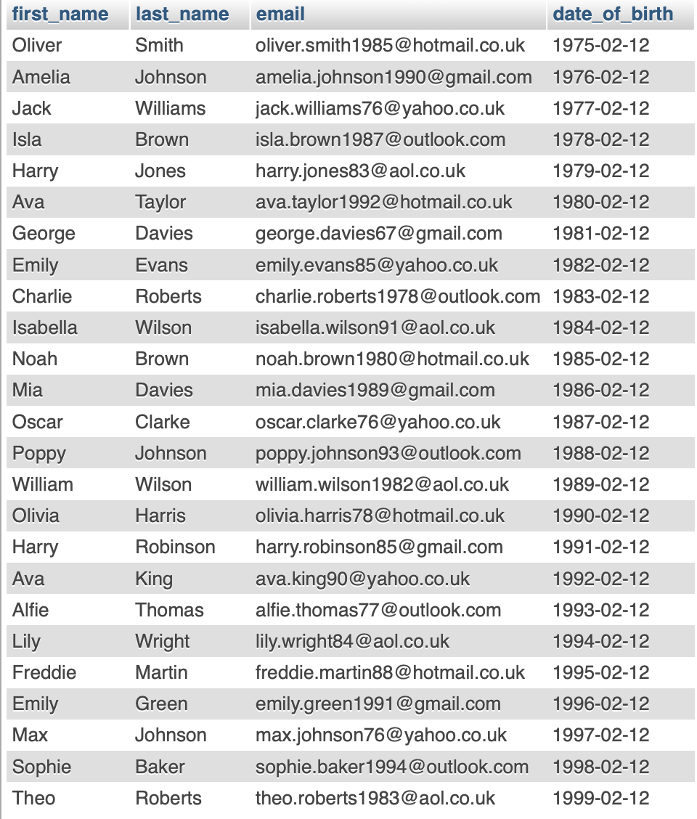

Filtering :

[SELECT](https://webhost1.eeecs.qub.ac.uk/phpmyadmin/url.php?url=https://dev.mysql.com/doc/refman/8.0/en/select.html) * FROM `Applicant` WHERE date_of_birth BETWEEN '1975-02-12' [AND](https://webhost1.eeecs.qub.ac.uk/phpmyadmin/url.php?url=https://dev.mysql.com/doc/refman/8.0/en/logical-operators.html%23operator_and) '2002-04-12';

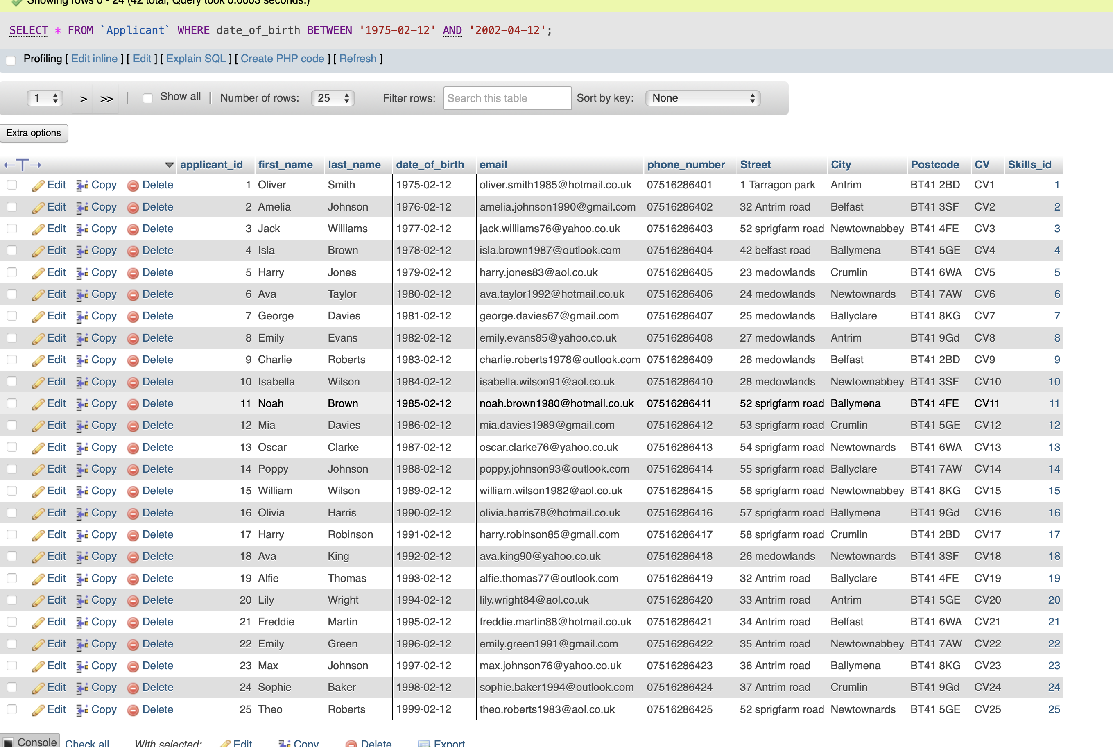

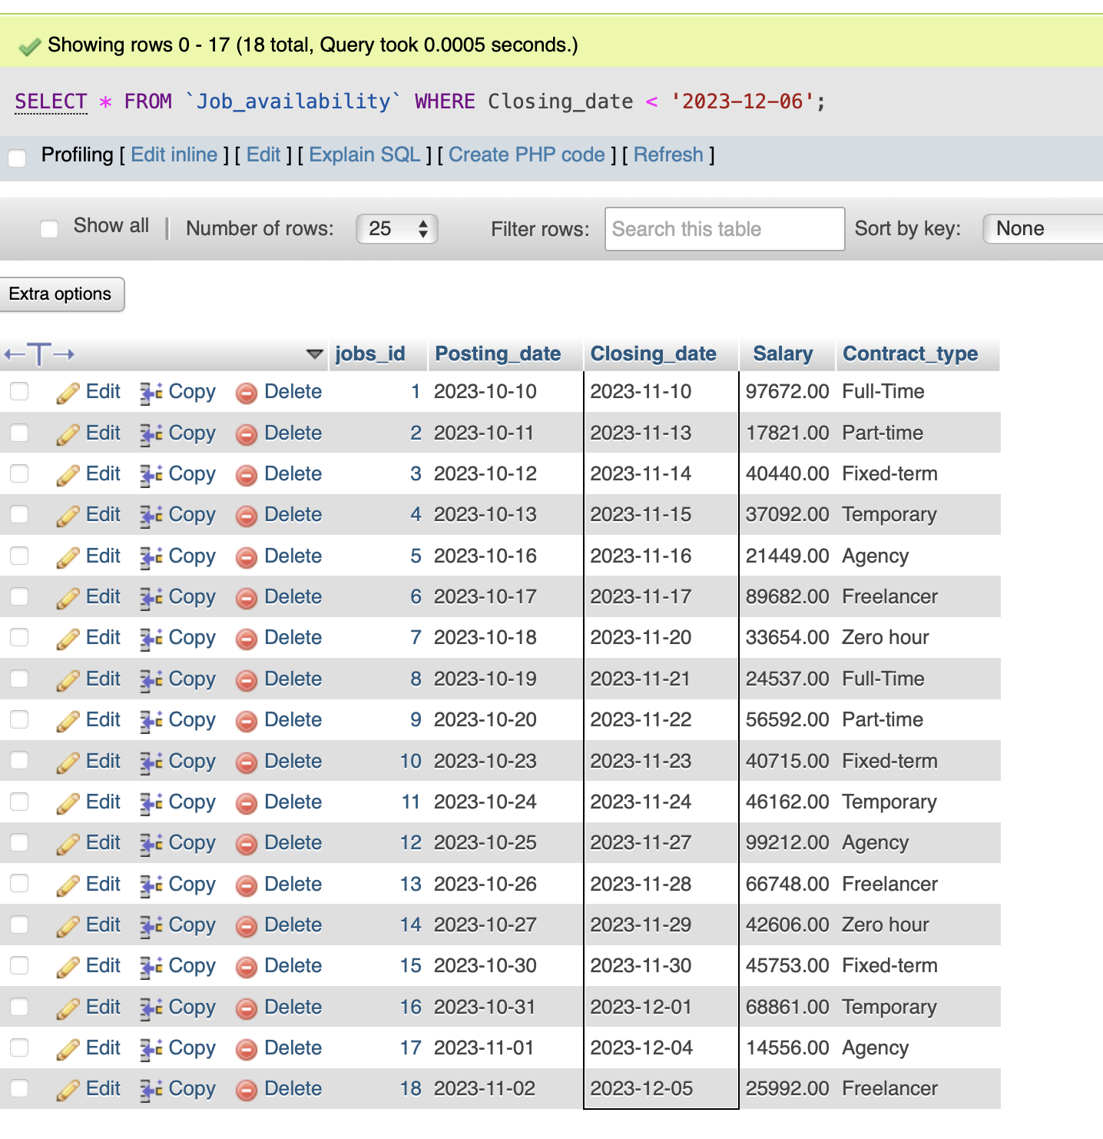

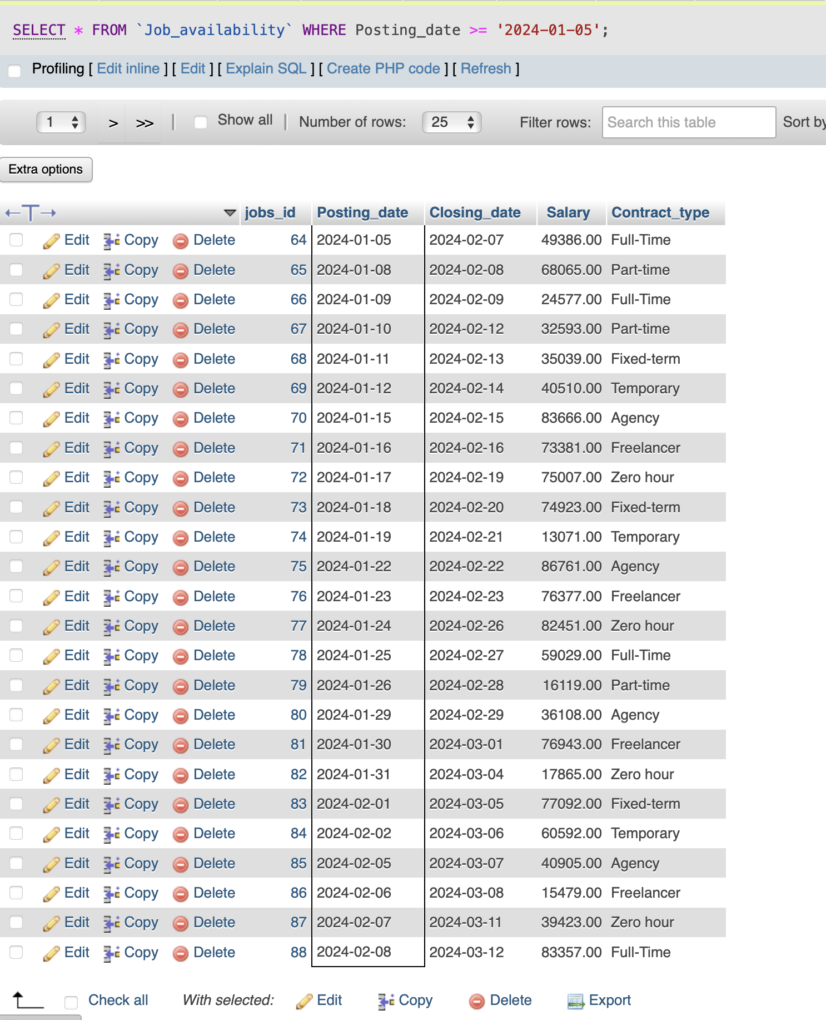

For the first part of the python connection SELECT All FROM Applicants_info  
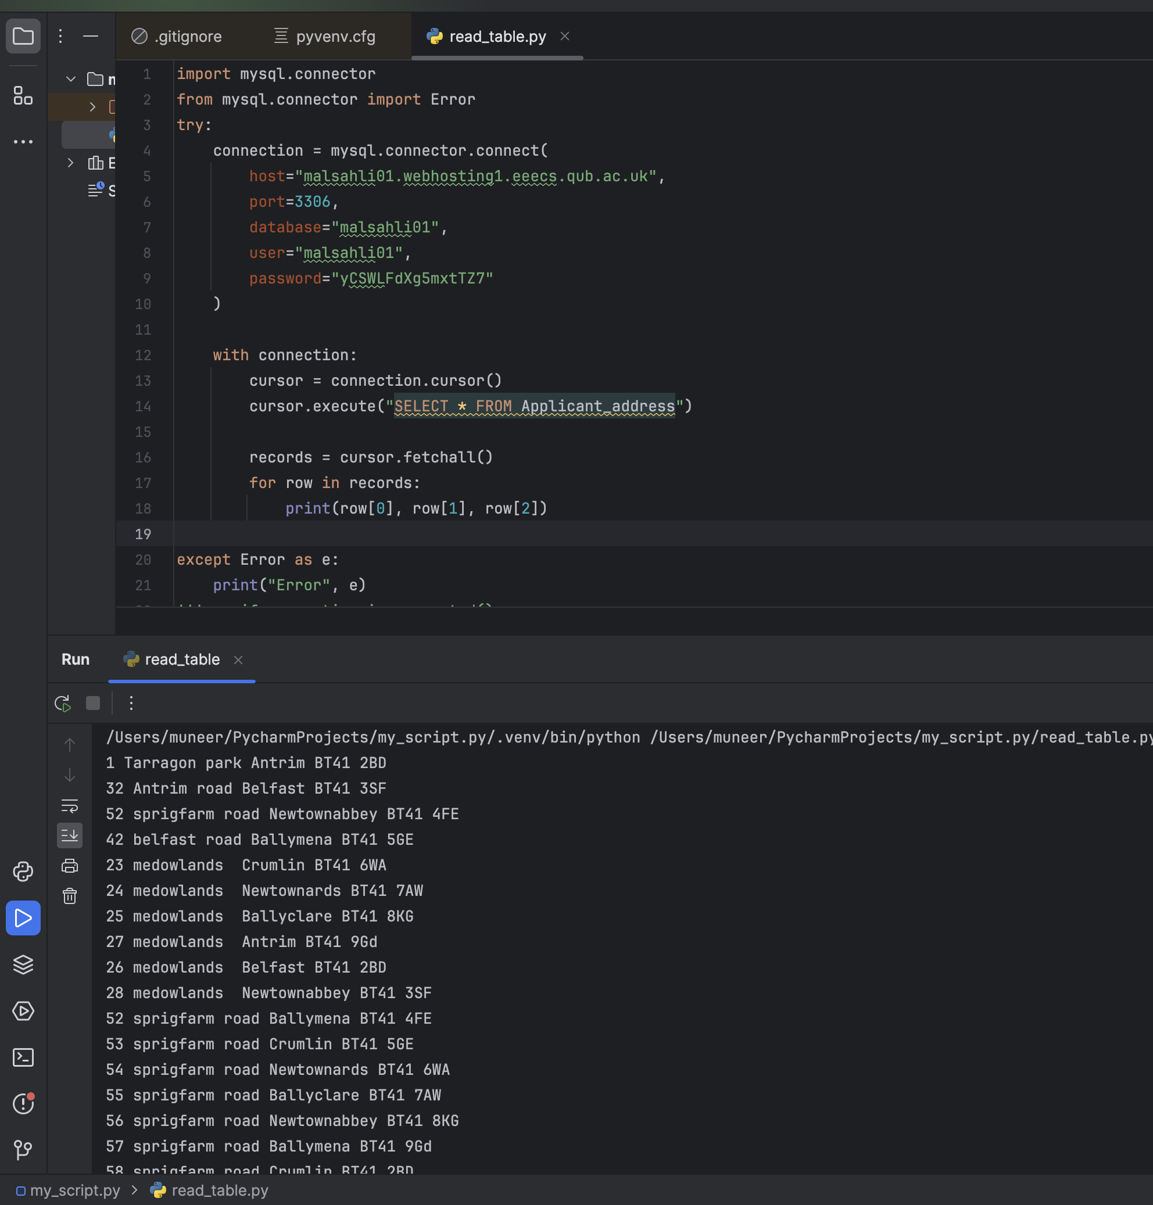

Python connection inserting data:

